**Title**: Common and unique network basis for externally and internally driven flexibility in cognition

**Authors**: Ziyi Huanga and Dazhi Yina, b, *

**Author affiliations**: a Shanghai Key Laboratory of Brain Functional Genomics (Ministry of Education), Affiliated Mental Health Center (ECNU), School of Psychology and Cognitive Science, East China Normal University, Shanghai 200062, China;

b Shanghai Changning Mental Health Center, Shanghai 200335, China

**\*Correspondence author**: Dazhi Yin (dzyin@psy.ecnu.edu.cn).

**Introduction**: Flexibility is a hallmark of cognitive control and can be driven externally and internally, corresponding to reactive flexibility (RF) and spontaneous flexibility (SF). RF refers to quick and adaptive adjustments to a changing environment, and SF refers to generating various ideas for a given topic or question (Diamond, 2013; Eslinger & Grattan, 1993). Previous work has illustrated the relevance of fronto-parietal functional networks and basal ganglia to different types of cognitive flexibility in children, adolescents, and adults (Kupis & Uddin, 2023). However, whether the development of reactive and spontaneous flexibility is mediated by the same or distinct functional networks remains largely unknown.

**Materials and Methods (Fig. 1)**: Cross-sectional and longitudinal behavioral assessments and resting-state functional magnetic resonance imaging (fMRI) data of participants aged 6-35 years were collected from the Enhanced Nathan Kline Institute Rockland Sample (Nooner et al., 2012; Tobe et al., 2022). A total of 196 (95 males) and 213 (106 males) participants were selected from fMRI datasets with different repetition time (TR of 1.4 s and 0.645 s), respectively.

The RF score was obtained by averaging z-scores of trail-making test and color-word interference tasks (switching condition). The SF score was obtained by averaging z-scores of verbal fluency and design fluency tasks (fluency condition), while the reactive and spontaneous flexibility (RSF) score was obtained by averaging z-scores of verbal fluency and design fluency tasks (switching condition). Higher scores indicate better cognitive flexibility.

Nodal flexibility (NF) and functional connectivity strength (FCS), derived from dynamic and static frameworks, respectively, were used. FCS was defined as the average strength of FC between a region and all other regions, and NF was quantified as the entropy of a region’s time-varying FC patterns (Yin et al., 2016). The FCS and NF were computed for each region and averaged for each cortical and subcortical (SUB) network (Schaefer et al., 2018; Yeo et al., 2011; Tian et al., 2020).

We first examined the age effects on different types of cognitive flexibility and the associations between cognitive flexibility and brain metrics. Based on that, we built nonlinear mediation models through the MedCurve toolbox (Hayes & Preacher, 2010) to explore the age-brain-behavior relationship. Furthermore, we predicted the follow-up cognitive flexibility (24-30 months after baseline visits) using the baseline brain metrics, when controlling for the baseline age and behavioral scores.

**Results**: (1) Quadratic effects of age were consistently observed on the RF, SF, and RSF scores (adjusted *R2* > 0.26, *ps* < 2 × 10-13) in both TR 1.4 s and TR 0.645 s datasets. (2) Functional metrics of the ventral attention (VAN) and fronto-parietal networks (FPN) were reproducibly correlated with various types of cognitive flexibility across datasets and brain metrics ( $|β|$ > 0.13, *ps* < 0.10). (3) The FCS or NF of the FPN mediated the relationships of age with the RF, SF, and RSF scores at age 11 and 17 (instantaneous indirect effect [$θ$] > 0.03), while the FCS of the VAN mediated the relationships of age with the SF score ( $θ$ > 0.08)(Fig. 2). (4) The NF of the VAN and SUB at baseline significantly predicted the follow-up RF score (*t* > 2.45, *ps* < 0.02), while the FCS or NF of the DAN at baseline predicted the follow-up SF score (| *t* | > 2.08, *ps* < 0.04).

**Conclusions**: The externally and internally driven flexibility exhibit similar developmental trajectories, and the FPN serves as the common network basis. Furthermore, our findings on the predictive roles of the VAN on reactive flexibility and the DAN on spontaneous flexibility provide deep insights into the neural substrates of different types of cognitive flexibility. Our study also suggests the importance of studying specific types of flexibility abnormalities in developmental neuropsychiatric disorders.

**Figures**



**Fig. 1.** An overview of the methodology and datasets. (A) Two types of cognitive flexibility: the TMT and CWI are considered reactive flexibility-specific tasks, whereas VF and DF are considered spontaneous flexibility-specific tasks. The common process of the two types is flexible cognitive control, and the key difference is that reactive flexibility is largely externally driven whereas spontaneous flexibility is mainly internally driven. (B) Two brain metrics are derived from temporally static and dynamic frameworks, respectively: functional connectivity strength (FCS) and nodal flexibility (NF). (C) Participants included in the final cross-sectional and longitudinal analyses in the datasets with different temporal resolutions: TR 1.4 s and TR 0.645 s. TMT: trail-making test; CWI: color-word interference; VF: verbal fluency; DF: design fluency; and TR: repetition time.

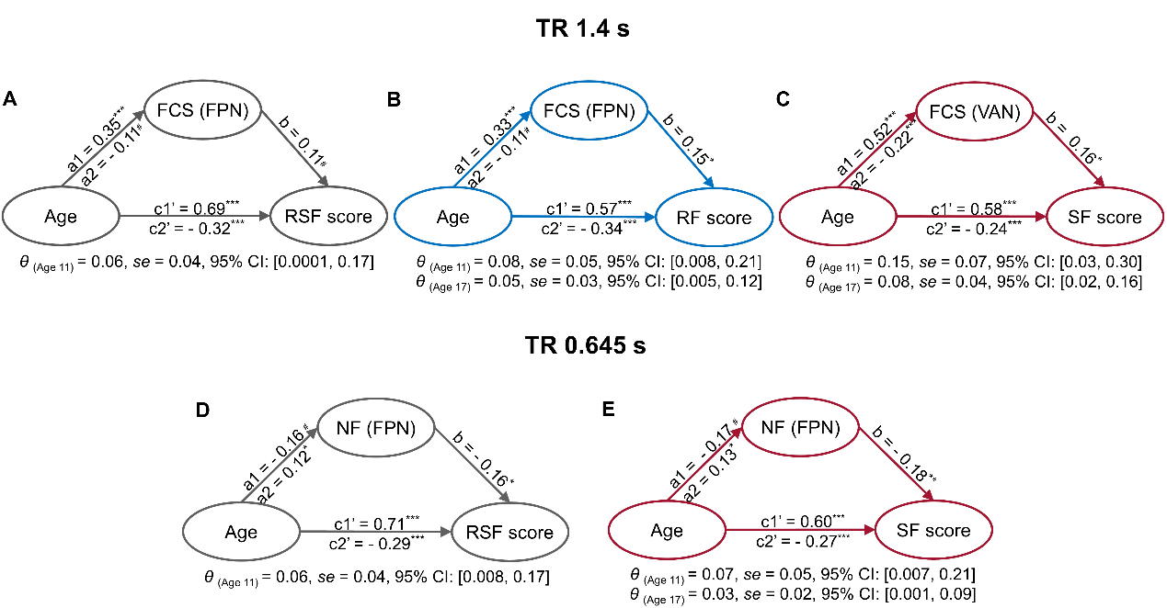

**Fig. 2.** Mediating effects of the functional brain metrics on the development of different types of cognitive flexibility. In the TR 1.4 s dataset, the FCS of the FPN mediated the development of RSF (A) and RF (B), and the FCS of the VAN mediated the development of SF (C). In the TR 0.645 s dataset, the NF of the FPN mediated the development of RSF (D) and SF (E). a1: linear effects of age on brain metrics; a2: effects of age2 on brain metrics; b: linear effects of brain metrics on cognitive flexibility; c1’: direct linear effects of age on cognitive flexibility; c2’: direct effects of age2 on cognitive flexibility; $θ$: Instantaneous indirect effects; CI: confidence interval. Standardized coefficients are shown. RF: reactive flexibility; SF: spontaneous flexibility; RSF: reactive and spontaneous flexibility; FCS: functional connectivity strength; NF: nodal flexibility; FPN: fronto-parietal network; VAN: salience/ventral attention network; # *p* < 0.1, * *p* < 0.05; ** *p* < 0.01; and *** *p* < 0.001.

**References**:

Diamond, A. (2013). Executive functions. *Annual Review of Psychology*, *64*, 135–168.

Eslinger, P. J., & Grattan, L. M. (1993). Frontal lobe and frontal-striatal substrates for different forms of human cognitive flexibility. *Neuropsychologia*, *31*(1), 17–28.

Hayes, A. F., & Preacher, K. J. (2010). Quantifying and testing indirect effects in simple mediation models when the constituent paths are nonlinear. *Multivariate Behavioral Research*, *45*(4), 627–660.

Kupis, L. B., & Uddin, L. Q. (2023). Developmental neuroimaging of cognitive flexibility: update and future directions. *Annual Review of Developmental Psychology*, *5*, 263–284.

Nooner, K. B., Colcombe, S., Tobe, R., Mennes, M., Li, Q., Hinz, C., Kaplan, M., Rachlin, A., Cheung, B., & Yan, C. (2012). The NKI-Rockland sample: a model for accelerating the pace of discovery science in psychiatry. *Frontiers in Neuroscience*, *6*, 32787.

Schaefer, A., Kong, R., Gordon, E. M., Laumann, T. O., Zuo, X.-N., Holmes, A. J., Eickhoff, S. B., & Yeo, B. T. T. (2018). Local-Global Parcellation of the Human Cerebral Cortex from Intrinsic Functional Connectivity MRI. *Cerebral Cortex (New York, N.Y. : 1991)*, *28*(9), 3095–3114. https://doi.org/10.1093/cercor/bhx179

Thomas Yeo, B. T., Krienen, F. M., Sepulcre, J., Sabuncu, M. R., Lashkari, D., Hollinshead, M., Roffman, J. L., Smoller, J. W., Zöllei, L., & Polimeni, J. R. (2011). The organization of the human cerebral cortex estimated by intrinsic functional connectivity. *Journal of Neurophysiology*, *106*(3), 1125–1165.

Tian, Y., Margulies, D. S., Breakspear, M., & Zalesky, A. (2020). Topographic organization of the human subcortex unveiled with functional connectivity gradients. *Nature Neuroscience*, *23*(11), 1421–1432.

Tobe, R. H., MacKay-Brandt, A., Lim, R., Kramer, M., Breland, M. M., Tu, L., Tian, Y., Trautman, K. D., Hu, C., & Sangoi, R. (2022). A longitudinal resource for studying connectome development and its psychiatric associations during childhood. *Scientific Data*, *9*(1), 300.

Yin, D., Liu, W., Zeljic, K., Wang, Z., Lv, Q., Fan, M., Cheng, W., & Wang, Z. (2016). Dissociable changes of frontal and parietal cortices in inherent functional flexibility across the human life span. *Journal of Neuroscience*, *36*(39), 10060–10074. https://doi.org/10.1523/JNEUROSCI.1476-16.2016